tCentric Hybrid™
Counter Height – Upholstered Backrest* |  | Midnight Black [t-MBUP-CH]  Light Grey [t-LGUP-CHG]
Backrest:  Midnight Black / Light Grey  - Front Upholstered Dual Curve Backrest (19"w x 25"h)  - 5” Patented Back Height Adjustment System  - Solid Back Cap  - tCentric Lumbar Support with Air Lumbar (pump)  Arms:  Midnight Black / Light Grey [G]  Options:  - tCentric Armrest Height & Lateral [TCL / TCLG]  - tCentric Armrest Height & Swivel [TC360 / TC360G]  - tCentric Armrest Height, Lateral & Swivel [TCL360 / TCL360G]  Seat:  - Dual Density Molded Polyurethane Foam  - Eight ply hardwood seat structure  - Tailored upholstery on seat pan (20”w x 19”d)  Options:  - Extra Small Seat (17 ½”w x 15 ½”d) [XSS]  - Small Seat (18 ½”w x 17”d) [SS]  - Plus Size Seat (22”w x 19”d) [PS]  - Extra Long Seat (20”w x 21”d) [XLS]  - Extra Deep Seat (22”w x 21”d) [XPS]  - Energy Absorbent Memory Foam [EA]  - Triple Density Foam [TDF]  - Non-Tailored Seat Pan [NTS]  Counter Height Mechanism:  - Independent Back Angle Adjustment  - Fixed Seat  - Seat Height  Options:  Midnight Black  - Modified Multi Tilt Mechanism (Seat slider, height and back angle adjustment only) [MT]  - Dedicated Task 2 Mechanism [DT2] | Pneumatic Lift (Seat Height):  Midnight Black / Light Grey  - 200 mm Pneumatic Lift (23 ½" – 30 ¾")  Options:  Midnight Black / Light Grey [G]  - 157 mm Pneumatic Lift (19 ¾” – 25 ½”) [157MM / G157MM]  - 267 mm Pneumatic Lift (25 ¾” – 35 ¾”) [267MM / G267MM]  Base/Footring/Glides/Casters:  - 26" Glass Reinforced Nylon (Midnight Black / Light Grey)  - Aluminum, Height Adjustable Footring (20” Diameter, 1 ¾” Thick Foot Platform)  - 1 ¼” Glides  Options:  - Lock-On Urethane Casters [LON]  - Lock-Off Urethane Casters [LOF]  - Dual Wheel Nylon Casters [NC]  - Dual Wheel Urethane Casters [UC]  - Single Wheel Nylon Casters [SW]  - Single Wheel Urethane Casters [SWU]  - 2 ¼” Glides [2G]  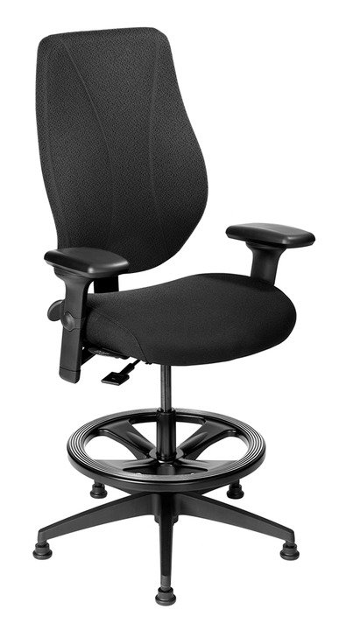  Additional Options:  Midnight Black / Light Grey [G]  - Adjustable Headrest [AHR / AHRG]  Measurements/Overall Dimensions:  Boxed Weight/Size: 56 lbs. / 6.7 cu.ft.  *Mixing of Midnight Black & Light Grey components is not an option.

